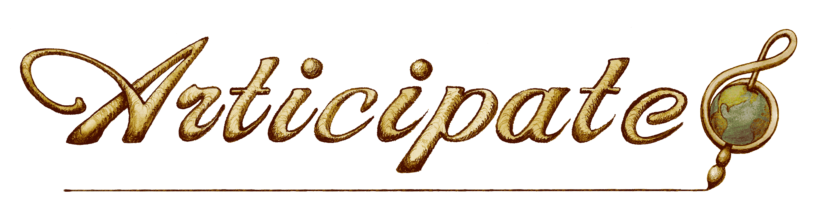
Board of Directors Quarterly Meeting
Minutes

Date: Monday, September 15, 2014
Time: Regular Session 6:00 – 8:00 PM
Location: Sarah’s Board Room (129 ½ 3rd Street)
6:00 PM – Regular Session call to order, welcome guests; Sarah called meeting to order 6:05pm. (Skipped ahead to financial report until quorum arrived)

6:02 PM – Approval of Agenda and Meeting Minutes from June 9, 2014- Jess suggested moving election of new members before Old Business. Suzanne motioned to approve amended agenda; John seconded the motion; vote unanimous in favor. Suzanne motioned to approve June 9 minutes; John seconded the motion; vote was unanimous in favor.
- Record Attendance- John, Jess, Bones, Sarah, Suzanne, Cam, Brink; Absent: Patty LaTille

6:05 PM – New Business
- John nominated Cam & Brink to the Board of Directors; nominations were accepted by both; Suzanne motioned to elect Cam Ziminski & Brink Messick to the Board of Directors. Sarah seconded the motion; vote was unanimous in favor.

6:15 PM - Financial Report- Jess reported that we are currently projecting a deficit because of two large grants that we denied, and 2 large grants that are pending. Our fundraiser, and hopefully several of our pending grants will be awarded, will help bring the budget back up to our projected levels. The board supports the staff moving money between budget line items to make the best use of our funds and ensure a high level of program spending. (see evaluation below for content suggestions to new financial policy).

6:25 PM – Old Business
- Grant report – Jess answered questions about the grants report
- Program report- Bones reported that WoW and Leon have both performed at Salida School and are scheduled to perform again; Valley Echos was well received even though income expected was not earned, will look into partnership with Salida HS drama club leader for a camp next summer in Salida; Wooden Rain Drops has 7 youth participants; Art Library on hold until facility is secured for Articipate.
- Scholarship report- Jess informed new board members that a small committee (Suzanne, Bones, Jess) reviews scholarship applications and scores them according to the rubric. Budget is on track, recent applications will be awarded in full.
7:00 PM - New Business
- New Board Member Orientation- Jess answered questions about the orientation packet.
- Evaluation
  - See financial management results (attached).
- Fundraiser 11/8- Bones reported that the November concert would be an “Articipate presents” concert to raise money and that we will also hold an Articipate showcase concert on December 11 at Salida High School. The 11/8 headliner will be Haunted Windchimes, opening Chimney Choir. The showcase concert will feature Wooden Rain (Adult and Youth) and Rock School. Board members are asked to sell 10 tickets each for the Haunted Wind Chimes concert. More ticket sales will be needed for the December fundraiser.
- Art Church- Bones reported that the church would like to work with Bones when they are able to ask for bids. Bones would be buying the building independently and asking Articipate to rent the facility to operate its programs. An arts center such as this would help Articipate grow its programs and raise donations.
8:00 PM – Meeting adjourned at 8:10pm
Next meeting dates:
October 27, concert planning, 6-7pm followed by Moonlight Pizza
Nov 17, fundraising planning meeting
Dec 11, 6pm program showcase concert at Salida HS
Jess will send a doodle to schedule the next quarterly board meeting- Dec/Jan

