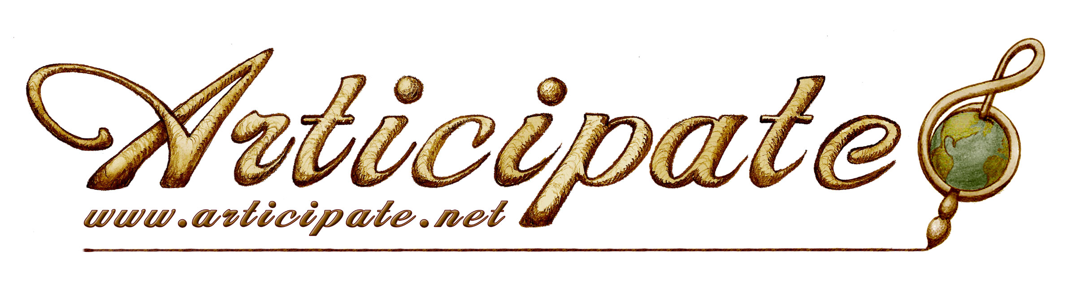
Colorado Nonprofit Association: Principles & Practices Organizational Assessment and Planning Tool Evaluation Results
Completed December 2013

Section 1: Governance and Leadership
The board completed a thorough review of the Governance and Leadership section and found that most questions could be answered as ‘in progress’ or ‘completed’. Questions that were answered with ‘not begun’ or ‘in progress’ with more to be done are as follows:

#3, 4- Need clarification for board job descriptions and legal responsibilities
#6a- Thorough budget review prior to approval has not yet been fully implemented
#6b- 990-EZ postcard not currently reviewed by the board
#8- No board evaluation has been completed to date
#19- Board members do not currently receive orientation/training
#20- Board recruitment, selection and term limits have not yet been developed
#29- Board diversification and increased recruitment needed; financial experts and literacy training needed for the board; legal experts needed

Based on these results, action planning will include the following:

#3, 19- Provide orientation annually and to new board members to review bylaws, job descriptions, finances, policies, etc.
#4, 19, 29- Obtain consultation/training in financial literacy and legal obligations of nonprofits (Chrissy Supples CRC, Small Business Alliance, Colorado Creative Industries)
#6a- Budget to be reviewed by the board in December, ready for March approval
#6b- 990-EZ postcard review by board before submission (Jan/Feb)
#8- Board will integrate a self-evaluation (board composition, operational structure, policies, ED compensation/performance, strategic plan, succession plan) into its annual meeting
#20- Term limits were discussed and due to a lack of board applicants, the board choose not to pursue any bylaw changes with regard to term limits at this time; recruitment activities will be tied to marketing plans for 2014

